

IMPLEMENT PLAN

**Version1.1**

**Quốc Nhân**

**05/11/2019**

**VERSION HISTORY**

|  |  |  |  |  |  |
| --- | --- | --- | --- | --- | --- |
| **Version #** | **Implemented**  **By** | **Revision**  **Date** | **Approved**  **By** | **Approval**  **Date** | **Reason** |
| 1.0 | Quốc Nhân | 05/11/2019 |  |  | Create Document implement plan version 1.0 |
| 1.1 | Quốc Nhân | 06/11/2019 |  |  | Update document v1.1 |
| 1.2 | Quang Vương | 09/11/2019 | Team | 09/11/2019 | Review and update |
|  |  |  |  |  |  |

Table of Contents

1. Introduction 3

1.1 Purpose 3

1.2 Intended audience 3

2. HUMAN RESOURCE 3

2.1 Role & Responsibility 3

3. IMPLEMENT PROCESS 3

4. OVERVIEW SCHEDULE 3

5. PRIORITY OF MODULE 3

6. REQUIRE KNOWLEDGE 3

7. IMPLEMENTATION ENVIRONMENT & TOOLS 3

7.1 Environment 3

7.2 Tools 3

8. REFERENCES 3

**List of Table**

table : 1 Intended audience 3

table : 2 ROLE & RESPONSIBILITY 3

table : 3 PrIORITY OF MODULE 3

FIGURE: 1 IMPLEMENT PROCESS 3

# 

# Introduction

## Purpose

* + This document describes in detail the process for real estate project implementation and is written on android, IOS operating systems.
  + This document will show how the team works to create the product.

## ****Intend audience****

|  |  |  |
| --- | --- | --- |
| **Intended Audience** | **Name** | **Reading Suggestions** |
| Implement Leader | Huỳnh Đạt | Deploy set of implement process include processes, describes for all member in team can understand and do right process. |
| Developer | Quốc Nhân  Quang Vương  Anh Minh  Như Phương | Read document to know implement process and according it to work in implement phase. |
| Project Manager | All of member | Read to know process of implement phase and tracking progress according to this process. |

**Table 1: Intended Audience**

# Human resource

## Role & Responsibility

|  |  |
| --- | --- |
| **Role** | **Responsibility** |
| Implement Leader | * Make plan & process in implement phase. * Training language programming for all member in team. * Assign task for team member. * Tracking and controlling progress of working in team according to WBS. * Responsibility to code main functions. * Report about progress to project Management (PM) weekly. * Responsibility to product. * Fix defects if occur. |
| Developer | * Implement the functions of system according to task assigned in WBS and detail design. |

Table 2: Role & Responsibility

# Implement process

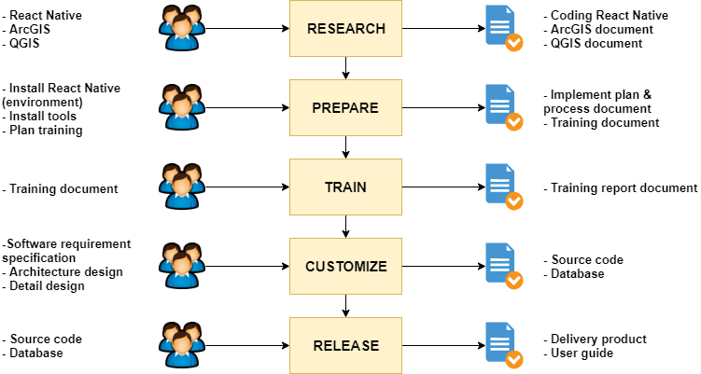

**Figure 1. Implement Process**

# Overview schedule

# Priority of module

|  |  |  |  |
| --- | --- | --- | --- |
| **Function** | **Id** | **Feature** | **Priority** |
| **Account management** | FR.01 | Login | High |
| FR.02 | Logout | High |
| FR.03 | Display account information | Medium |
| FR.04 | Search for personnel | Medium |
| FR.05 | Display personnel list | Medium |
| FR.06 | Show company chart | Medium |
| FR.07 | Display company policies | Medium |
| FR.08 | Add accounts | High |
| FR.09 | Delete accounts | High |
| FR.10 | Edit accounts | High |
| FR.11 | Accounts classification | High |
|  | | | |
| **Project management** | FR.12 | Show project list | High |
| FR.13 | Search for the project | Medium |
| FR.14 | Show project details | Medium |
| FR.15 | Add project | High |
| FR.16 | Edit project | High |
| FR.17 | Project classification | High |
|  | | | |
| **Statistical management, reporting** | FR.18 | Displaying business results | High |
| FR.19 | Displaying business results graph | High |
| FR.20 | Display table comparing business results | High |
|  | | | |
| **Business trip manager** | FR.21 | Sign up for business trip | High |
| FR.22 | Browse business trip | High |
| FR.23 | Business trip history | High |
|  | | | |
| **Management quit** | FR.24 | Register to quit your job | High |
| FR.25 | Approval of leave | High |
| FR.26 | History of leave | High |
|  | | | |
| **Other functions** | FR.27 | Birthday staff notification | Low |

**Table 3: Priority of module**

# Require knowledge

Require all member in Team must have knowledge:

* Languages: React native & JavaScript.
* Using QGIS

# Implementation environment & tools

## Environment

- Run on Window platform: window 7, 8 and later version (Data management)

- Database:

- Programming language: React native, JavaScript

- Web browser: Google chrome, Fire Fox, Internet Explorer

- Smartphone: Android 5.0, IOS 5.0.1 & later version

## ****Tools****

Team will use necessary tool to develop the app:

* Genymotion
* Android Studio
* React Native
* QGIS

# References